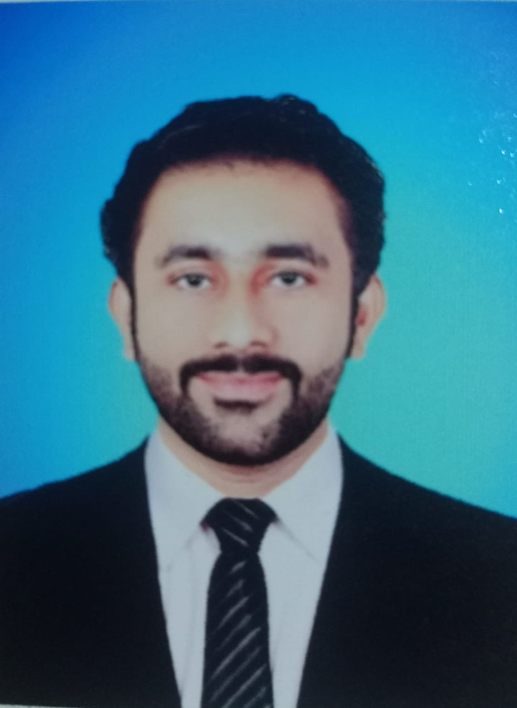
Curriculum Vitae
Dr. Ghulam Ali
PMDC REGISTRATION # 905837-02-M
Adress: Zaffar housing scheme near ayub hotel bypass
Hyderabad
E-mail: drghullama@gmail.com
Cell # 0300-0940919
OBJECTIVE:
To work for a challenging position in competitive and dynamic environment to build personal credibility through efficient performance, knowledge and skills for long term carrier development and growth.

PERSONAL INFORMATION:

- Father’s Name : Ghulam Asghar
- Date of Birth : 05-07-2001
- C.N.I.C # : 45303-7329351-7
- Domicile : Nausheroferoz (Sindh)
- Nationality : Pakistani
- Religion : Islam
- Marital Status : Single

ACADEMIC QUALIFICATION:

QUALIFICATION | INSTITUTE | YEAR
- Matriculation | B.I.S.E Sukkur | 2016
- Intermediate | B.I.S.E Sukkur | 2018
- M. B. B. S | ISRA UNIVERSITY HYDERABAD | 2023

PROFESSIONAL EXPERIENCE:

- House Job at LIAQUAT UNIVERSITY HOSPITAL HYDERABAD STARTED FROM 11-05-2024 Till 10-08-2024 in Medicine Department
- House Job at LIAQUAT UNIVERSITY HOSPITAL HYDERABAD STARTED FROM 11-08-2024 Till 10-11-2024 in Nephrology Department
- House Job at LIAQUAT UNIVERSITY HOSPITAL HYDERABAD STARTED FROM 11-11-2024 Till 10-02-2025 in Surgery Department
- House Job at LIAQUAT UNIVERSITY HOSPITAL HYDERABAD STARTED FROM 11-02-2025 Till 10-05-2025 in Urology Department
REFERANCE:

- Will be furnished on demand

