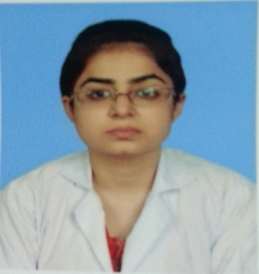 |  | DR FAIZA MASOOD  RESIDENT MEDICAL OFFICER  7+ YEARS CLINICAL EXPERIENCE
Profile  Seeking a good platform to strengthen my career and add to my medical knowledge & improve in patient care, to enhance my reputation as an excellent medical practitioner.  Contact  PHONE:  03003924721  EMAIL:  faizamasoodamir@gmail.com  ABOUT ME  -mARRIED  -MUSLIM  - CAN SPEAK:  URDU, ENGLISH, SIRAIKI  ACHIEVEMENTS  - Distinction in General Surgery (Final year MBBS)  - Distinction in Biochemistry (First year MBBS)  - 2nd position in Biochemistry Presentation (2nd year MBBS)  - 2nd position in Pharmacology Poster competition (3rd year MBBS) |  | EDUCATION  MBBS - LIAQUAT NATIONAL HOSPITAL- 2014  INTERMEDIATE - DEFENCE AUTHORITY DEGREE COLLEGE FOR WOMEN - 2008  MATRICULATION - GULISTAN S.A.L GIRL’S SECONDARY SCHOOL - 2006  WORK EXPERIENCE  OMI HOSPITAL - RMO  JUNE 2022 – TILL DATE (2+ YEARS)  NATIONAL MEDICAL CENTER - RMO  DECEMBER 2016 TO JUNE 2022 (5.5 YEARS)  LIAQUAT NATIONAL HOSPITAL - INTERN  5TH MAY 2015 - 5TH MAY 2016.  cOURSES AND WORKSHOPS  - 1 year Post Graduate Certificate Course In Family Medicine (Liaquat National Hospital from March 2022 to March 2023) (WHO Endorsed)  - All CPSP Workshops for MCPS qualification (Basic Surgical Skills, Computer and I.T, Communication Skills, BLS refresher course)  - 10th Neurology course (Aga Khan University from 16 January to 6 march 2014)  Others:  - Workshop on oxygen therapy (Liaquat National Hospital on February 2016)  - Basic Life Support for health care provider (Liaquat National Hospital on 15th June 2015)  - Basic interpretation of ECG (Liaquat National Hospital on 10th July 2015)  - Advanced Airway Management (Liaquat National Hospital on 24th July 2015)  - 17th National Health Sciences Research Symposium “Non-Communicable diseases (Aga Khan University on 26-27 February 2014)  - Workshop on practical approach to implement T.B infection control and Pakistan (Liaquat National Hospital on 1st March 2012)  - Basic Nursing Skills overview course (Liaquat National Hospital on 24-26 February 2012)

