 | 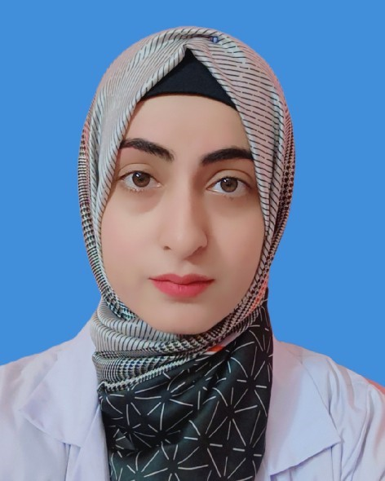
  Dr Almas
house no c21 street 5 wakeel colony larkana
03133670073 almasjalbani@gmail.com

Academic Details
Shaheed mohtarma benazir bhutto medical university larkana
BDS - Bachelor of Dental Surgery. FCPS-1, Pmdc no 28786-D, 70.25%, 2020

Work Experience
Chandka medical collage teaching hospital larkana
House officer , Mar 2021 - Mar 2022
Role : House officer
Care Dental Clinic
Dental surgeon, Apr 2022 - Nov 2023
Role : patient diagnosis and treatment
Orthodontic and aesthetics dental clinic Dental surgeon, Dec 2024 - till date

Field of Interest
Clinical Work: Strong interest in engaging with patients, providing hands-on healthcare, and contributing to clinical operations to enhance patient outcomes.
Teaching and Academic Mentorship: Passionate about delivering lectures, guiding students, and fostering an engaging learning environment to enhance their academic and professional growth.

Skills
Skillful of all basic and dental procedure

Industrial Exposure
Industrial Visit at:
Platinum Pharmaceuticals (Pvt.) Ltd.

Reference
Dr Bashir Ahmad jalbani
Assistant professor
Bibi Aseefa Dental Collage Larkana bashirjalbani890@gmail.com
0333 2522603


(Dr Almas)

