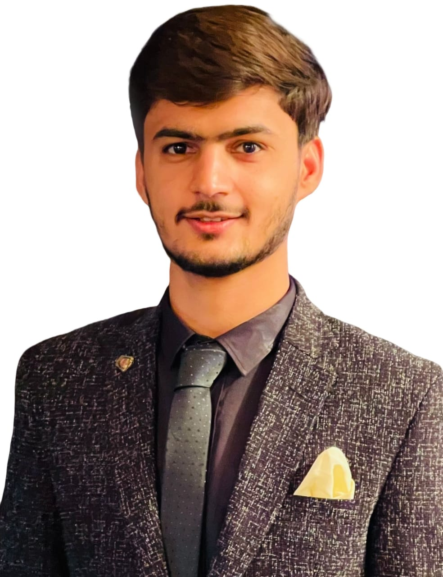
Junaid Mahmood
Address: Banglow no.518B Township sukkur airport road sukkur, Sindh
Mobile: +923313171521, +923068330766
Email: junaidansari9845@gmail.com

Professional Affiliation

- Apr 2022: Pakistan Medical and Dental Council (PMDC), Islamabad

Professional Exam

- August 2024: Passed Fellowship of College of Physicians and Surgeons (FCPS)-Part-1
College of Physicians and surgeons Pakistan (CPSP), Karachi

Education

- 2017 – 2022: Bachelor of Medicine and Bachelor of Surgery (MBBS)
Chandka Medical College, Shaheed Mohtarma Benazir Bhutto Medical University (SMBBMU), Larkana, Sindh, Pakistan

- 2015 – 2016: Higher Secondary Certificate (HSC II)
Board of Intermediate and Secondary Education (BISE) Larkana, Sindh

- 2013 – 2014: Secondary School Certificate (SSC II)
Board of Intermediate and Secondary Education (BISE) Larkana, Sindh

Professional Experience

- 4th Jan 2024: Locum Casualty Medical Officer
Department Of Accident and Emergency, Chandka Medical Civil Hospital Larkana, Sindh
  - I Have Worked as a Locum Casualty Medical Officer In Department Of Accident And Emergency, Chandka Medical Civil Hospital Larkana Where I Managed Adult Emergency Cases Including Diabetic Ketoacidosis, Hemorrhage, Stroke, Shock Etc. I'm Very Good at Doing Adult CPR And Monitoring Vitals.

- 4th Oct 2023 – 3th Jan 2024: Medical Officer
The Larkana Medical Center Larkana, Sindh
  - I Have Worked As A Night Resident Medical Officer And Managed Common Emergency As Well Opd Cases Of Medicine, Pediatrics, Surgery, Gynecology And Obstetrics.

- 4th Sep 2023 – 3th Oct 2023: Medical Officer
Children's Emergency Hospital-Child Life Foundation Larkana, Sindh
  - I Have Worked as A Medical Officer and Managed the Pediatrics Emergency Cases. I'm Very Good at Maintaining Vitals, Doing Cardiopulmonary Resuscitation, Passing Iv Canula, N/G And Urinary Catheters.

- 9th Jul 2022 – 8th Jul 2023: House Officer
Chandka Medical College Teaching Hospital, Shaheed Mohtarma Benazir Bhutto Medical University (SMBBMU), Larkana, Sindh

  - July 2022 – Oct 2022: Pediatrics
Under the supervision of consultants, learned to manage the neonates, infants and children of various illness especially asthma, dehydration, bronchiolitis, diarrhea. Learned how to implement Integrated Management of Newborn and Childhood Illness (IMNCI) on children during this tenure.

  - Oct 2022 – Jan 2023: Medicine
As a trainee, gained experience regarding management of the medical diseases such as diabetes, hypertension, diabetic ketoacidosis (DKA), malaria, typhoid fever etc.

  - Jan 2023 – Apr 2023: Surgery
Learned to manage patients with medical issues related to surgery and assisted in various surgical procedures.

  - Apr 2023 – Jul 2023: Orthopedic.
Observed and learned to manage various cases related to department.
Skills

- Proficient in Microsoft Windows and Microsoft Office (Word, PowerPoint).

Extracurricular Activities

- I am a huge fan of international and domestic cricket and football.
- Play badminton and table tennis whenever get the chance.
- Love to read novels from different genre.

