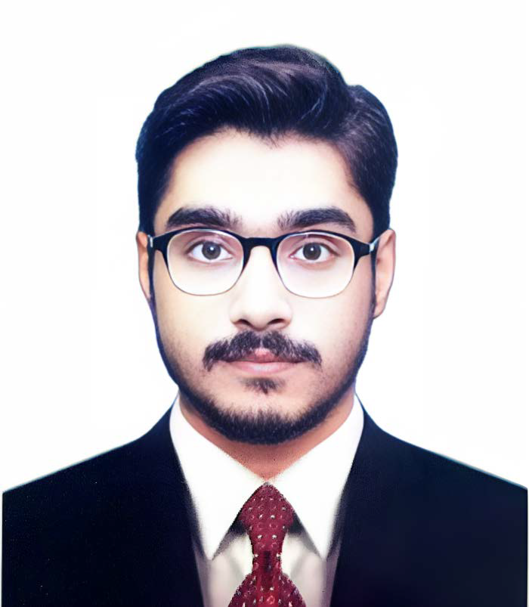Abdul Sami
Objective
Detail-oriented doctor committed to upholding the highest standards of medical excellence. Proven ability to deliver accurate diagnoses, implement effective treatment plans, and achieve optimal patient outcomes.

Contact
Communication Address:
Sher Afzal Building Near Ziauddin Clifton Dental OPD Gate No 06, Karachi

Permanent Address:
Hindu Muhallah Lakh Pati Road Near Pepsi Agency Shahdadkot, District Qamber Shahdadkot

Phone:
+92 3110346318

Email:
sa298884@gmail.com

Personal Information
- Date of Birth: February
26th, 1999

- Nationality: Pakistani

- CNIC: 43406-0427806-9

- Religion: Islam

- City: Shahdadkot

Language
- English
- Urdu
- Sindhi
Education
- Bachelor of Medicine and Bachelor of Surgery
(MBBS)
  - Passing Year:- 2022
  - Grade:- "A"
  - Marks Achieved (%):- 81.3%
  - University:- Shaheed Muhtarma Benazir Bhutto Medical University

- Intermediate (Pre-Medical)
  - Institute:- Government Degree College Shahdadkot
  - Passing Year:- 2016
  - Grade:- "A1"
  - Marks Achieved:- 951 Marks
- Matriculation (Science)
  - Institute:- Darya Khan Public School Shahdadkot
  - Passing Year:- 2014
  - Grade Achieved :- ‘B’
  - Marks Achieved:- 585 Marks
Carrier
House Officer:-
- Hospital:- Liaquat University Hospital Hyderabad
- Department's:- 4 Month (General Medicine)
  - Month (Gastroenterology)
  - Month (General Surgery)
3 Month (Orthopedic Surgery)
Interests
- Playing Cricket
- Reading Books
- Bodybuilding
Disability
- I would like to disclose that I have bilateral footdrop, I use the Afos Plastic Shoes but I will ensure that my disability won’t affect my quality of work.

